Install a Program without Admin Permissions

This doesn’t work for all programs, but it’s worth a shot.

Typically, installing a program using an exe or msi file for all users on a computer requires administrative permissions, which regular physics users don’t have. These permissions are required because the default installation location is C:\<program sub-path>, C:\Program Files\<program sub-path>, or C:\Program Files (x86)\<program sub-path>. However, you may install the program for only yourself by changing the installation directory to C:\Users\<your username>\AppData\Local\<program sub-path>. Also, ensure that the program is not set to install for all users. For example, to install Python for yourself on your computer:

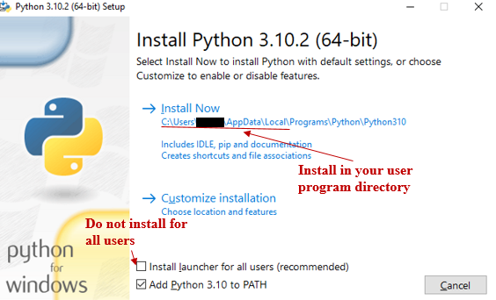

See this [link](https://www.addictivetips.com/windows-tips/install-an-app-for-a-single-user-on-windows-10/) for more info.